**PocketDeen**

# **Analysis**

**Project title**

PocketDeen.

**My idea**

My idea is an app/website called PocketDeen. It’s an app/ website to help Muslims stay connected to their religion and become better practicing Muslims. It can also help non-Muslims learn about Islam and understand it more. I got this idea because of my belief in Islam, and I would enjoy making something that helps people with their belief or helps people just to gain knowledge of Islam.

This app will contain prayer times, prayer notification and a prayer tracker to help people first to get in touch with the prayers of Islam. Then we will add a google maps API and a compass to both the nearest mosque and to Hajj (pilgrimage)- to make the lives easier for people who use the app/website.

## My plan to find out more

* **What has inspired me.**

I have been inspired been most by my religion (Islam) and I would love to make an app/website to help Muslims and non-Muslims learn more about the religion.

* **What kind of thing do I need to find out more about?**

I plan to research other Islamic apps and websites to understand what features they include and how they are structured. This will help me decide what is useful, what’s already overused, and what gaps I can fill with PocketDeen. I will also analyse their user interfaces and check reviews to learn what users complain about or wish they had. This research will help guide my design choices and avoid repeating mistakes made by other developers.

* **I will ask people questions.**

I will speak to members of my local mosque and gather their feedback about what they would like to see in an Islamic app. This will help me understand the real needs of users rather than just based on what I think is useful. Their ideas will allow me to make the app more user-friendly. I also want to ask them about things that are missing from other apps they’ve used, so PocketDeen can fill those gaps.

## **Analysis: 3 - research**

**• The 3 products that have choose to take inspiration from.**

**Figure 1 Pillars**

**Figure 2 Pillars**

**Figure 3 Pillars**

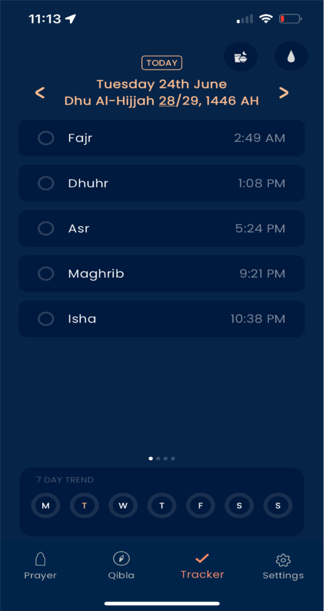

|  |  |
| --- | --- |
| **Things would like to take forward/adapt into my project/what I like.** | Things I don’t want to use in my project/don’t like. |
| Nice clean user interface. This app is understandable to any practicing Muslim. | I don’t like its not understandable by non-Muslims. I would make it so |
| The functions are what I want in my app/website. I like them because they are simple, clean, and easy to use. | The functions are too basic. For non-Muslims, it doesn’t teach them or help them understand the religion. |
| The compass function is a function that I want to be added. Its clean and simple. I would add a function to direct people to the houses of god(Mosques). | With this function I would just ad more directional text to help non-. |
| The timings of prayer function are good and minimalistic | I would just make it more inclusive as some people don’t understand that Arabic language like non-don’t know the prayer Maghrib and don’t know how to pray that prayer. (Maghrib is the prayer that you pray at sunset.) |

**Figure 1 Muslim Pro**

**Figure 2 Muslim pro Quran (the holy book for Muslims)**

**Figure 3 Muslim pro lessons and videos to help people gain more knowledge**

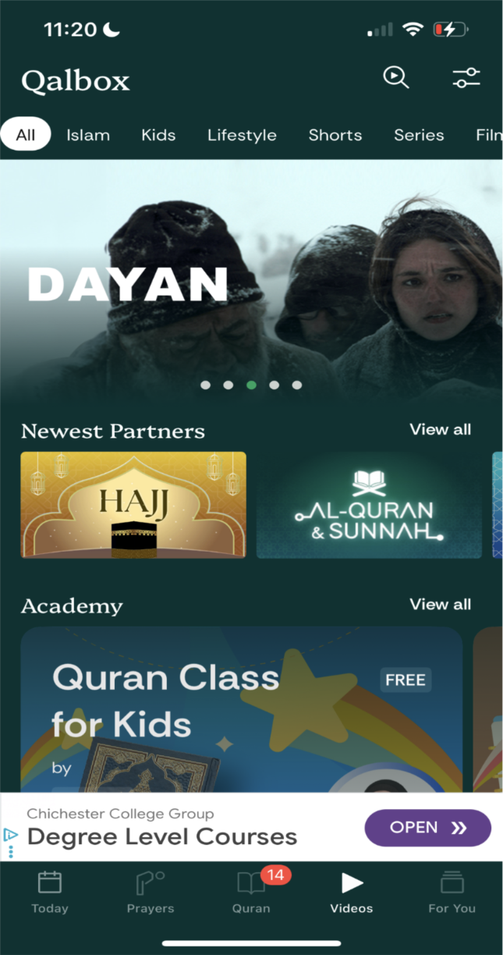

**Figure 4 Muslim pro Dua page (Dua means wish)**

**Figure 5 timings of prayer**

|  |  |
| --- | --- |
| **Things would like to take forward/adapt into my project/what I like.** | Things I don’t want to use in my project/don’t like. |
| The front page has a clean and simple interface. The layout is easy to follow, with clear directions that make it easy to use. The colour scheme is minimal and calming, which helps make the app look professional. | The front page still doesn’t have options for people to understand what the Islamic words mean. It’s not inclusive for people who are new to Islam or non-Muslims who want to learn. |
| The features are nice and easy to use. They are professional and have a clean design. Everything looks well-made and works smoothly. There are a lot of functions that I would like to adapt for my own app, like the tracker and the prayer times. These features help users stay on top of their Deen in a simple way. | Some parts of the app are not explained well for new users. People who don’t know much about Islam might get confused with some of the words or features. It feels like the app was made only for people who already understand the religion. |
| The Quran feature is easy to read and has bilingual options so you can translate it into your own language. It also has transliteration to help you pronounce the Arabic words properly. There’s even an audio feature where someone reads it out loud, which makes it easier to follow and learn. | The app has endless scrolling, which gets annoying after a while. It makes you feel tired just trying to find the right section. If you accidentally click on a chapter and then go back, it takes you all the way to the top again. This wastes time and makes the experience frustrating. |

|  |  |
| --- | --- |
| The dua function is clean and professional. It has searches and buttons that take you to the right place. | Doesn’t have any current things I don’t like |
| The video feature helps people understand the prophets lives (my peace and blessing be upon them all). they do have English videos to non-Muslims understand. | It not understandable on where to start if your learning about the religion. |

**Figure 1 muslimandquran -** [**Muslim and Quran - Athan & Prayer Times, Quran, Hadith, Qibla, Ramadan, Dua & More. | Muslim and Quran | Muslim and Quran**](https://muslimandquran.com/) **Home page**

**Figure 2 muslimandquran -** [**Muslim and Quran - Athan & Prayer Times, Quran, Hadith, Qibla, Ramadan, Dua & More. | Muslim and Quran | Muslim and Quran**](https://muslimandquran.com/) **features page**

**Figure 2 Quran page -** [**https://muslimandquran.com/quran**](https://muslimandquran.com/quran)

**Figure 4 research page -https://muslimandquran.com/islamic-media**

|  |  |
| --- | --- |
| **Things would like to take forward/adapt into my project/what I like.** | Things I don’t want to use in my project/don’t like. |
| The front page has a clean and simple design. It uses nice, soft colours that make it look fresh and easy to use. It also supports different languages, which makes it easier for people from different backgrounds to use. It also has a function on how to | N/A. currently I like the front page its clean and simple |

|  |  |
| --- | --- |
| The features are nice and easy to use. They are professional and have a clean design. Everything looks well-made and works smoothly. There are a lot of functions that I would like to adapt for my own app, like the tracker and the prayer times. These features help users stay on top of their Deen in a simple way. | Some parts of the app are not explained well for new users. People who don’t know much about Islam might get confused with some of the words or features. It feels like the app was made only for people who already understand the religion. |
| The Quran feature is easy to read and has bilingual options so you can translate it into your own language. The Quran page has easier access as they are side by side easy to change. | This is on website so there’s not much scrolling issue. |
| Mosque finder function.  Easy google map’s clear location on direction | N/a |
| The prayer timing function is clean and simple. It clearly shows all the prayer times for the day, so users know exactly when to pray. It’s easy to read and doesn’t feel confusing or overloaded. This makes it really helpful for both new and regular users. As they have a guid on how to pray | I don’t like the colours used—they’re too plain and don’t stand out. The design feels a bit too simple and could look more modern or engaging. A better colour scheme would make the website more eye-catching and interesting to use. |
| There is a research page that lets people find an imam (like a priest or a religious guide) to help them learn more about Islam. I like that it gives users a way to ask questions and get proper religious guidance. You can also read articles about Islam, which helps people understand different topics in more detail. I like how it gives both learning and support in one place. | I don’t like this page because it has too much text all in one place. It looks a bit messy and hard to follow, especially for someone new to Islam. There are too many headings, and it’s not always clear where each one goes or what it’s for. |

## Analysis 4 - Stakeholders

The people who will use the app/website are Muslims who want to be better with there faith and keep track with there prayers. Non-Muslim people who wish to be more knowledgeable in the religion. This is an all-inclusive App to help all people to connect with Islam in an easy way. There is no matter in gender and aimed for people who wish to be more knowledgeable of Islam.

They will be involved in the beginning of the design to help build the foundations of my app/website.

## Requirements

I have made a Microsoft form to see what my stakeholders would want to see first.

This was to know what my stakeholders where more interested in.

I proposed if they wanted a more complex design or a simpler design to try to best fit their needs.

The complex menu includes lots of features like directions to mosques, how to pray guides and a tracker to help people keep track of their prayers and a lot more.

The simple menu includes a direction to pray, prayer times and a tally(like simplistic features that Muslims need to keep track)

Based on the survey they chose the complex menu.

The next task on the survey was to ask my stakeholders what they wanted most.

I gave them a list to place in order depending on what they wanted most.

This was so I can place my priority in jobs my stakeholders wanted first.

They placed it in the order [prayer times, direction of prayer, direction of mosques and an option to help people understand more of the religion].

From my stakeholders responses they wanted to place the functions in first then place the more difficult functions later

I gave a question to my stakeholders to see if they would want other features so I can try to implement it.

This was so I can further improve my app/website and work on the needs of the stakeholders.

The suggestion I personally liked the most was to include directions to halal food places. However, I understand that this might be challenging to implement, so I plan to add it after I finish working on directions to the nearest mosques.

|  |  |  |  |  |
| --- | --- | --- | --- | --- |
|  | Feature | Explanation | Justification | Importance |
| 1 | A complex design  (Menu) | A Menu where it will display multiple features that will also explain what to do and how to do it. For instance, prayer times would be displayed and there will be an option if they would want a (how to prayer guid) | In the two apps I have researched and the website I realised it was a common function they would display their times of prayer in the front menu. I also realised this what my stakeholders want as they have chosen the complex menu. | Essential |
| 2 | Prayer times | A simple display of the prayer times | This feature was listed first at the top of the survey and was suggested by the stakeholders. It was also included in every app/ website I researched**.** | Essential |

|  |  |  |  |  |
| --- | --- | --- | --- | --- |
| 3 | Direction of prayer | A feature that has a compass that points to Kaaba (The place of pilgramage) | Muslims must face the Kaaba in their five daily prayers, as practiced by the Prophet Muhammad (peace be upon him). | essential |
| 4 | Direction of mosques | Allows users to find the nearest mosque. | This was placed number 3 in my survey and helps bring convenience to people |  |
| 5 | A feature that places a how to(like pray) |  |  |  |

## Self-assessment

I believe my work is in the range of 5–8 marks. I have identified and described some limitations of the proposed solution, and in some cases I have explained them in more detail. However, I am not fully confident that I have met the standard required to reach the higher tier.

-------------------------------------------------------------------------------------------------------------

# **Design**

## GUI

*Figure 1 Options/search*

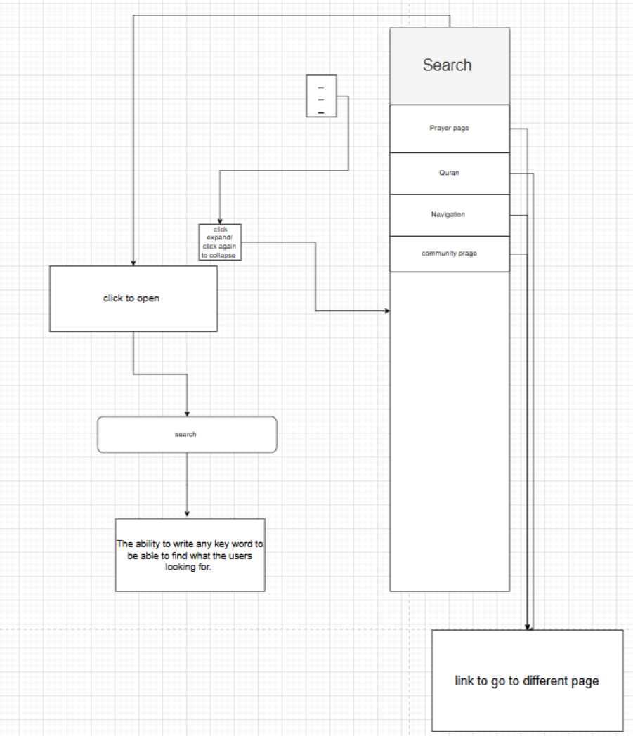I decided to create this search and navigation flow to make my app easier for users to interact with. The main reason for including a search bar is to allow users to quickly access specific content, such as prayer times, Quran references, or community features, without needing to scroll or click through multiple menus. This improves efficiency and reduces user frustration.

The expandable menu option (click to open/close) provides a clean and simple interface. This is important because people who want quick access to religious information on the go, for example during travel or at work. A collapsible menu avoids clutter while still keeping the most important pages accessible.

I also added the ability for users to type any keyword into the search function. This makes the app more flexible and user-friendly, as people may use different terms to find the same thing. For example, someone could search “Quran” or “Surah” and still find the relevant page. This reduces the chance of users feeling lost or unable to find what they are looking for.

Finally, I made sure each search result and menu item links directly to the relevant page. This ensures smooth navigation and helps the app feel more professional and reliable. By designing the flow this way, I focused on **usability (easy to use), accessibility (clear layout), and efficiency (fast navigation)**, which are all key design principles for apps.

*Figure 2 Homepage*

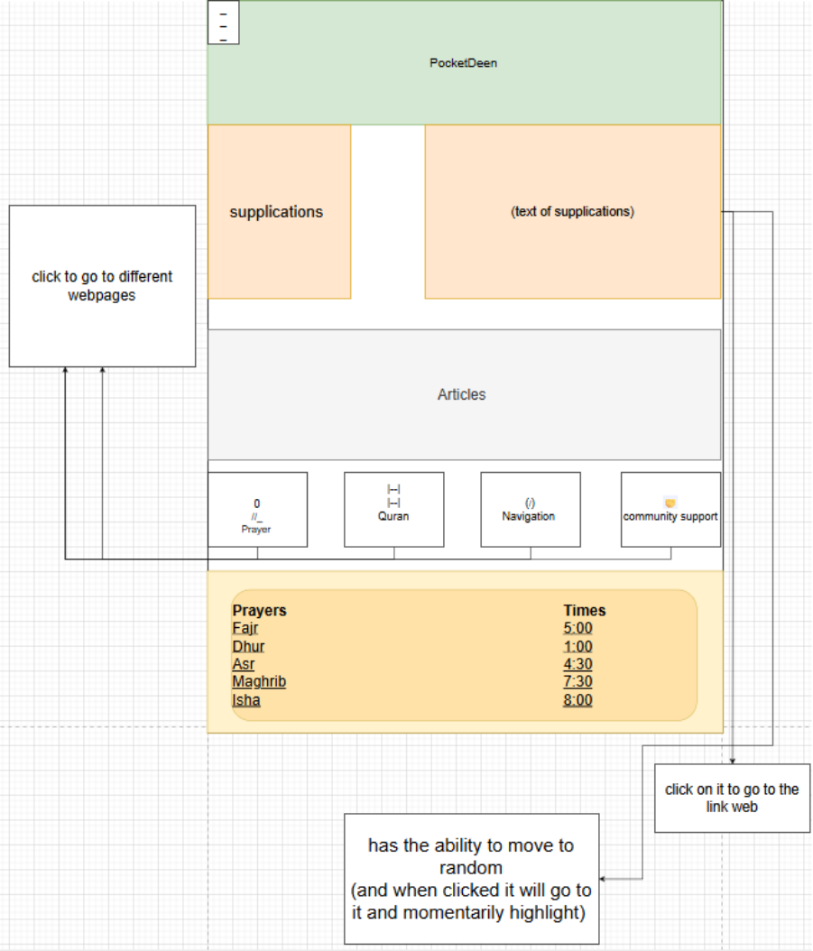

I made this design, so the Homepage is easy for people to use. I added things like supplications, Quran, articles, navigation, and community support because these are the main features users will need. I also put the prayer times at the bottom of the page. This is important because people check prayer times every day, so having them shown straight away saves time and makes the home more useful.

I also included features like being able to click to move to different pages or highlight links. This makes the app more interactive and stops it from feeling boring. The buttons at the bottom give clear ways to move around the app, but the random movement option adds something extra for users who like exploring. This means the app works well for different types of people while still being simple to follow.

*Figure 3 prayer page*

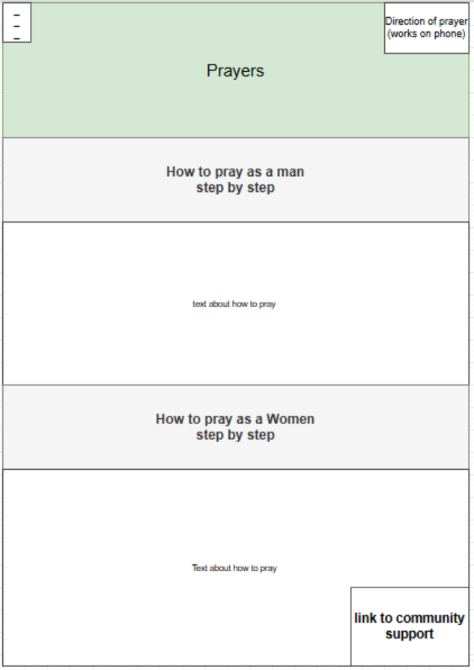

The prayer page is for people who want to learn how to pray in a clear and simple way. I decided to make it its own page so that everything about prayer is kept in one place and easy to find. This also helps the app look less crowded and more organized, which makes it easier for stakeholders and users to focus on what they need.

*Figure 4 Article*

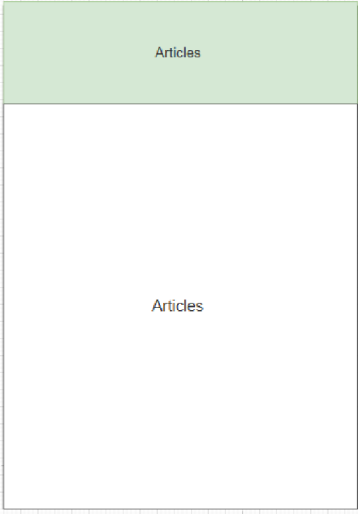

The articles page was made to give users extra information about Islamic topics. This is important because it allows people to learn more about their faith in their own time. By keeping all the articles on one page, it makes the app more organized and stops the other sections from feeling too crowded.

I also made this page so users can always come back and find useful information, like reminders, history, or advice. This means the app is not only about prayer times and the Quran but also about learning and personal growth. It gives stakeholders more value because the app supports both daily practice and long-term knowledge.

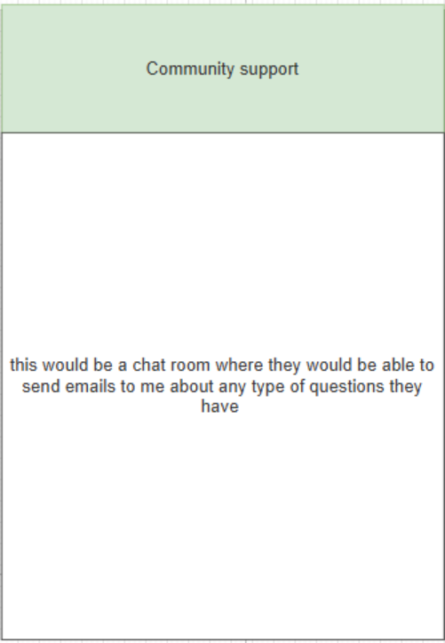

Theres nothing much to say about this page. I created this part of the website because users want to just ask any question they can, because with religion comes with a lot of questions that need to be answered, and I am not able to place every single detail on my website.

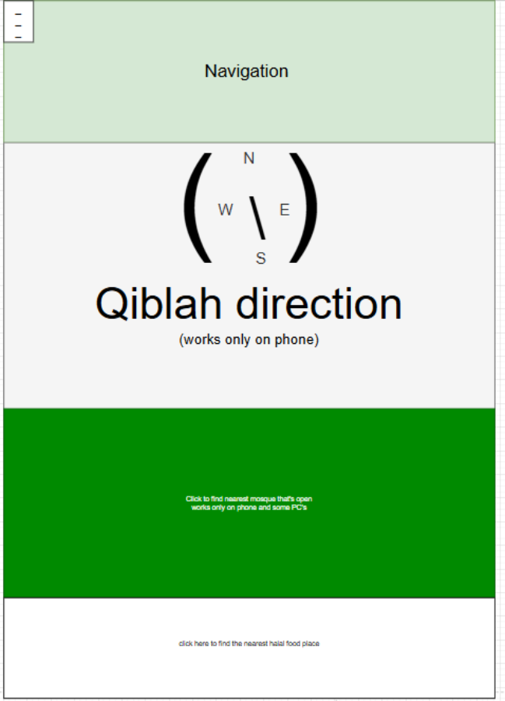

This page of my website is created to help people who want to be able find the nearest mosque and to find halal food to make them better in their faith. The compass to hajj (the pilgrimage) is created for people who want to pray at their homes or if they in an unfamiliar place to give them ease while trying to pray.

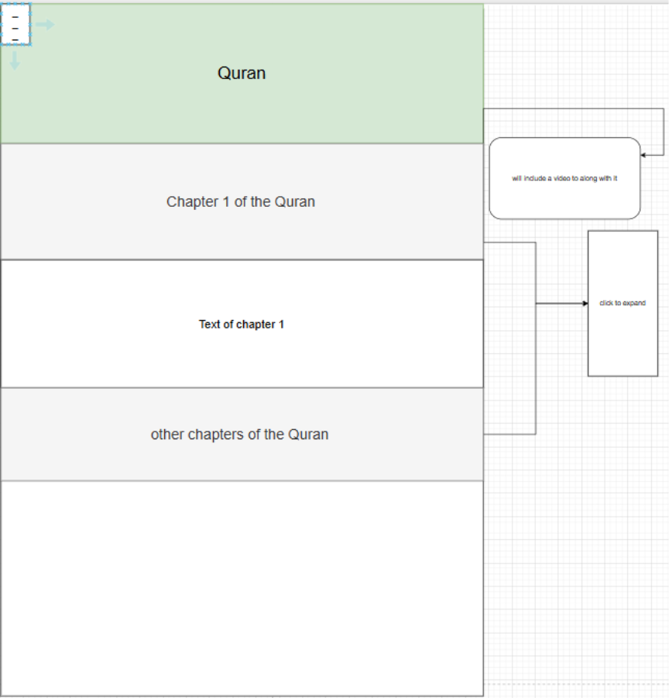

The Quran page is created to help people gain in knowledge of the Quran. I will split each chapter of the Quran and place them in a closable button so it's easier to read then 1 big chunk of text. On the top of each chapter will include a video link so the users can listen to how it sounds being read in Arabic.

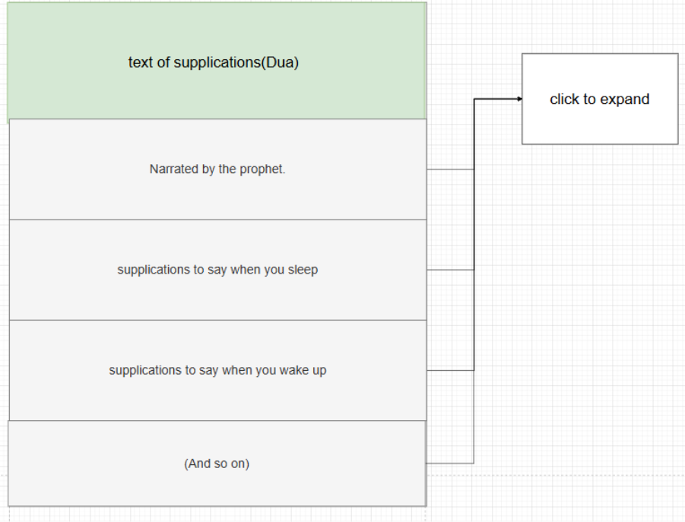

This page is for people who want to supplicate in the way the prophets may peace and blessings be upon them and their companions. This part of the website is the same as the quran the text would be able to collapse into a button and expand and i believe this would be useful for the stake holders.

## Structure diagram

I created this structure diagram to organise my website and show how the features link together. The main section is PocketDeen, and from it I divided the site into prayer, Qur’an, navigation, learning, and community. Each part then has smaller features, like prayer times, Qur’an translation, or nearest mosques, so the layout is clear and easy to follow. I did this because it helps me plan the website better and makes it easier for users to find what they need.

## Development plan

**Stage Explanation**

In this stage, I will focus on building themain featuresof the website. These include the prayer page, Quran section, articles, navigation, and community support. I will also add a search bar so users can type keywords to quickly find information. Another feature will be the prayer times table, which shows the five daily prayers. This makes the app more useful and organized for the users.

For the structures, I will set up text files or arrays to store information such as prayer times, supplications, and articles. This will make it easier for the app to load and display content. Later, I could also use a database if I want the app to handle bigger amounts of data, like saving user questions in the community support section.

The algorithms I will use include searching through the data when users type in the search bar, highlighting links when clicked, and loading the correct page when a button is pressed. I will also use simple loops and conditions to check user input and display the right information. These algorithms will make the app interactive and responsive, so users can move around smoothly without confusion.

|  |  |  |  |  |  |  |
| --- | --- | --- | --- | --- | --- | --- |
| Test No. | Subroutines | Test description | Test data | Expected outcome | Actual outcome | Type of test |
| 1.Home page |  |  |  |  |  |  |
|  | supplications | Does the program display text and rotate to display different supplications | STR | The text displays and displays different texts | / | / |
|  | Articles | Displays important information about the world each day | str | Displays important information about the world each day | / | / |
|  | To click the different buttons | Being able to press on like the supplications and it takes you to the supplication page and if you press on a text, it would take you to that text | str | To click on a button and it takes you to a page. | / | / |
|  | Prayer times | Prayers that display the appropriate times to pray. | str |  | / | / |
| Hamburger menu |  |  |  |  | / | / |
|  | Prayer page | Users press to go to page | str | To click on a button and it takes you to a page. | / | / |
|  | Quran page | Users press to go to page | boll | To click on a button and it takes you to a page. | / | / |
|  | navigation | Users press to go to page | boll | To click on a button and it takes you to a page. | / | / |
|  | Community page | Users press to go to page |  | To click on a button and it takes you to a page. | / | / |
|  | Search bar key word | The ability to typer any key word like (Quran) and takes you to the page but also gives you suggestion like a surah in the Quran |  | To take the user to the page they have typed. | / | / |
|  | Search bar words | Write a series of words like (I want to learn the night supplications) |  | The ability to take the user to a specific area of the website by typing a series of words and highlight the text to help them find it | / | / |
|  | Hamburger menu | Expandable and collapsible. |  | When the users click on the Hamburger it will expand and when they click again it will collapse | / | / |
| How to Pray (prayer site) |  |  |  |  |  |  |
|  | How to pray as a man | The text that's displayed when the button (how to pray as a man) |  |  |  |  |
|  | How to pray as a women | The text that's displayed when the button (how to pray as a woman) |  |  |  |  |
| Navigation direction |  |  |  |  |  |  |
|  | Compass to hajj | the needle point to hajj |  | The needle will point in the direction to hajj for iPhone no matter where they are |  |  |
|  | Maps | The map will locate the nearest open mosque. |  | The map should locate the nearest mosque like in google maps. |  |  |
|  | Halal food places | Helps users find halal restraints. |  | The map should locate the nearest halal food places like in google maps. |  |  |
| Quran |  |  |  |  |  |  |
|  | Open and colipasel buttens for the quran | / |  | / | / | / |

-------------------------------------------------------------------------------------------------------------------------------------

# **Iterative design**

## Algorithms – flowchart

*Figure 1 Homepage*

**Homepage flow chart**

The homepage algorithm is designed to best fit the stakeholders needs.

I placed load homepage to load everything on the website first.

These are the features I added.

* **Hamberger menu** – To allow the users to easily locate information they need from the website.
* **Dua list(supplication)** – Created for the convenience of the user. In Islam, its good supplicate before you start on your activity.
* **Symbols**: To allow the user to locate a page they want by clicking the symbol. To make it ease for all the users.
* **Prayer times:** Prayers are the most important part of Islam, and the timings are crucial. So, I placed them at the bottom of the homepage.

*Figure 2 homepage supplication feature*

**Supplication (Dua) Flow Chart**  
The supplication flow chart is designed to help users easily access and read duas (supplications) on *PocketDeen*. It aims to meet the needs of my stakeholders by offering an interactive and simple way to learn and reflect on Islamic prayers. The algorithm starts when the user clicks the supplication text, leading them to the dua section if they choose to continue. This ensures the website reacts smoothly to user actions while keeping navigation easy to follow.

These are the features I added:

* **Supplication button** – Allows users to access a list of duas directly from the homepage.
* **Interactive input** – When the user clicks, the page responds instantly, helping create a dynamic and engaging experience.
* **Automatic quotes** – Every 10 seconds, a new Islamic quote appears to inspire users and remind them of their faith while browsing.
* **Decision points** – If the user chooses to view supplications, they are taken to the dua page; if not, they stay on the homepage.

This design supports users who want quick spiritual reminders or to read specific duas, making *PocketDeen* both useful and spiritually uplifting.

*Figure 3 Hamberger menu*

**Prayer Flow Chart**  
The prayer page flow chart is designed to meet the needs of my stakeholders by making it easy for users to learn and access prayer information. I created this flow to show how users can navigate the prayer section clearly and without confusion.

These are the features I added:

* **Prayer button** – Allows the user to access the prayer page directly from the homepage. If the user doesn’t press it, they continue browsing without interruption.
* **How to pray (male/female)** – I added two separate options to show respect for religious and cultural differences in prayer practices.
* **Community support** – Helps users connect with others and find guidance, creating a supportive online Muslim community.
* **Expandable/Collapsible button** – Keeps the layout clean and easy to use, especially for users on smaller devices.
* **Hamburger menu** – Makes navigation simpler by letting users find what they need quickly.
* **Return to homepage** – Allows users to easily go back without getting lost on the website.

This flow ensures that *PocketDeen* remains easy to navigate and accessible for all users, helping stakeholders quickly find the Islamic content or support they need.

Figure 4 prayer link/ page

**Prayer Flow Chart**  
The prayer page flow chart is designed to meet the needs of my stakeholders by making it easy for users to learn and access prayer information. I created this flow to show how users can navigate the prayer section clearly and without confusion.

These are the features I added:

* **Prayer button** – Allows the user to access the prayer page directly from the homepage. If the user doesn’t press it, they continue browsing without interruption.
* **How to pray (male/female)** – I added two separate options to show respect for religious and cultural differences in prayer practices.
* **Community support** – Helps users connect with others and find guidance, creating a supportive online Muslim community.
* **Expandable/Collapsible button** – Keeps the layout clean and easy to use, especially for users on smaller devices.
* **Hamburger menu** – Makes navigation simpler by letting users find what they need quickly.
* **Return to homepage** – Allows users to easily go back without getting lost on the website.

This design makes PocketDeen more accessible, respectful, and user-friendly for Muslims wanting to learn or revise how to pray.

Figure 5 Quran section

**Quran Flow Chart**  
The Qur’an flow chart is designed to help users easily navigate and read different chapters of the Qur’an on *PocketDeen*. The purpose of this design is to make the reading experience organised, simple, and respectful for the user. It starts when the user clicks the *Qur’an* button, taking them directly to the Qur’an page if they choose to proceed. This makes the navigation smooth while also allowing users to stay on the homepage if they prefer.

These are the features I added:

* **Each chapter section** – Lets users view individual Surahs (chapters) clearly and access them without confusion.
* **Expandable/Collapsible buttons** – Added to keep the layout clean and make it easier for users to focus on one chapter at a time.
* **Hamburger menu** – Allows quick access to other pages, helping users move between sections easily.
* **Community support** – Included to give users a space for discussion or help, promoting a sense of unity and learning.

This design benefits stakeholders by making the Qur’an accessible, easy to read, and well-structured, ensuring *PocketDeen* remains both user-friendly and spiritually valuable.

## Code documentation – Website

This is all a HTML template that’s created by Open AI model Chat GBT 5 at 11:11PM on the 14/10/2025 | Link <https://chatgpt.com/c/68eec52a-4514-8331-b857-28cefc342e52>

Result

This was done to create a template of HTML, as I am mainly doing it in JavaScript. I will change the HTML code to fit my preference, and I will write the JavaScript to make my website functional for both computers and Phones.